HR EMPLOYEE ATTRITION ANALYSIS

STUDENT NAME : Muppudathi S
YEAR : II Year
COLLEGE CODE : 104
COLLEGE NAME : CSI Jayaraj Annapackiam College , Nallur.
DEPARTMENT : B.sc Computer Science
SEMESTER : IV Semester
ROLL NO : 24081041802112121
NMID : asmsu10424081041802112121
TITLE : HR EMPLOYEE ATTRITION ANALYSIS
GITHUB LINK :
DATE : 21.06.2026

1.ABSTRACT
Project Overview
Employee attrition is one of the major challenges faced by organizations. High employee turnover can increase recruitment costs, reduce productivity, and affect overall business performance. This project focuses on analyzing employee attrition data using Python and Data Analytics techniques. The dataset contains employee-related information such as age, department, salary, experience, and attrition status. The project uses Python libraries including Pandas, NumPy, Matplotlib, and Seaborn for data preprocessing, analysis, and visualization. Data cleaning techniques were applied to handle missing values and duplicate records. Exploratory Data Analysis (EDA) was performed to identify patterns and trends affecting employee turnover. Various visualizations such as bar charts and pie charts were used to represent attrition trends. The analysis revealed that factors such as salary level, department, and work experience significantly influence employee attrition. The project provides meaningful insights that help organizations develop effective employee retention strategies and improve workforce management. Overall, the project demonstrates how data analytics can support data-driven decision-making in human resource management.

2. PROBLEM STATEMENT

Many organizations experience high employee turnover, which results in increased hiring costs, loss of skilled employees, and reduced productivity. Understanding the reasons behind employee attrition is important for improving employee satisfaction and retention. This project aims to analyze employee data and identify the key factors contributing to employee attrition. The insights generated from this analysis can help organizations make informed decisions to reduce turnover and improve employee engagement.

3. OBJECTIVES

- To analyze employee attrition data.
- To identify the factors affecting employee turnover.
- To perform data cleaning and preprocessing.
- To visualize attrition trends using charts and graphs.
- To generate meaningful business insights
- To support data-driven decision-making.

4. PROJECT SCOPE

This project focuses on analyzing employee attrition data using Python in Google Colab. The project includes data cleaning, preprocessing, exploratory data analysis, visualization, and interpretation of results. The findings can help organizations understand employee behavior and improve retention strategies

5. TECHNOLOGIES USED
Development Environment
- Google Colab
- Python 3
Programming Language
- Python
Libraries Used
- Pandas
- NumPy
- Matplotlib
- Seaborn
Dataset Source
- Employee Attrition Dataset (CSV File)

6. APPLICATION FLOW

Step 1: Data Collection

Employee attrition dataset is collected in CSV format.

Step 2: Data Loading

Dataset is loaded into Google Colab using Pandas.

Step 3: Data Cleaning

Missing values, duplicate records, and inconsistencies are handled.

Step 4: Data Analysis

Employee data is analyzed based on department, salary, experience, and attrition status.

Step 5: Data Visualization

Charts and graphs are generated to identify trends and patterns.

Step 6: Insight Generation

Key findings are derived from the analysis.

Step 7: Conclusion
Recommendations are provided to reduce employee attrition.
7. KEY PYTHON DATA ANALYTICS CONCEPTS USED

- Data Handling
- Data Cleaning
- Exploratory Data Analysis (EDA)
- Data Visualization
- GroupBy Operations
- Filtering and Sorting
- Statistical Analysis

8. EXPECTED OUTPUT

The project produces meaningful insights about employee attrition patterns. It provides:

- Dataset Preview
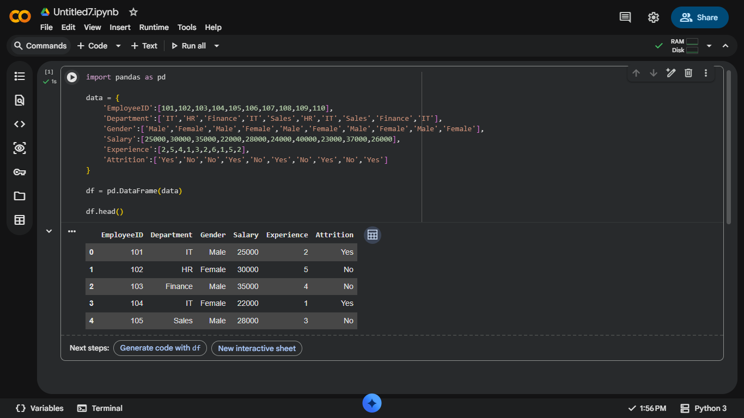
- Cleaned Employee Dataset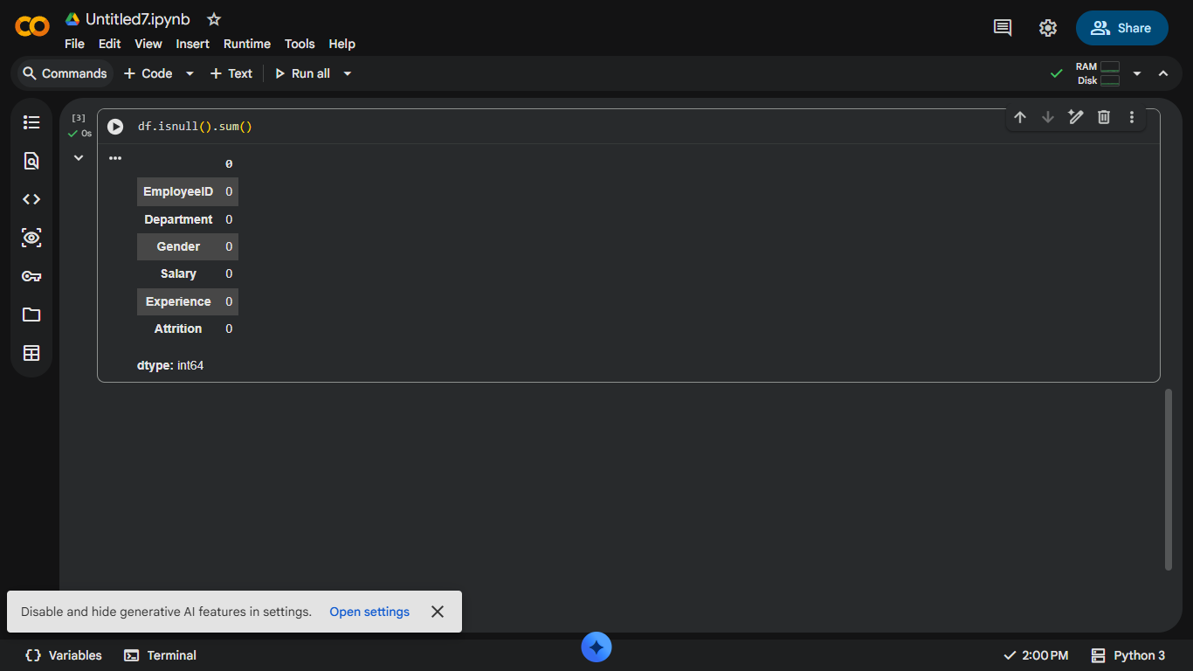
- Department-Wise Attrition Analysis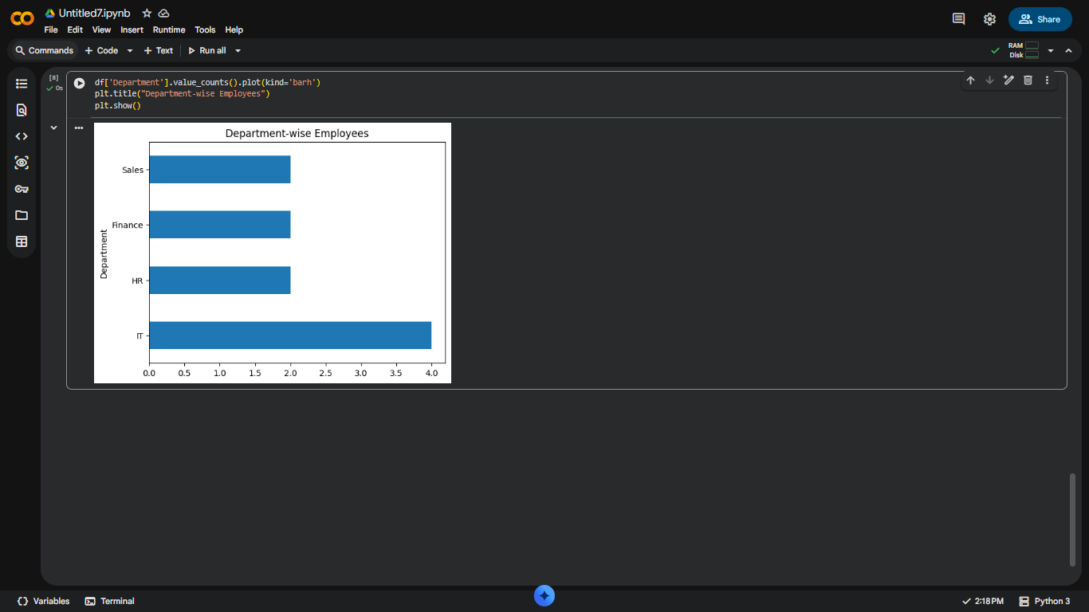
- Salary-Wise Attrition Analysis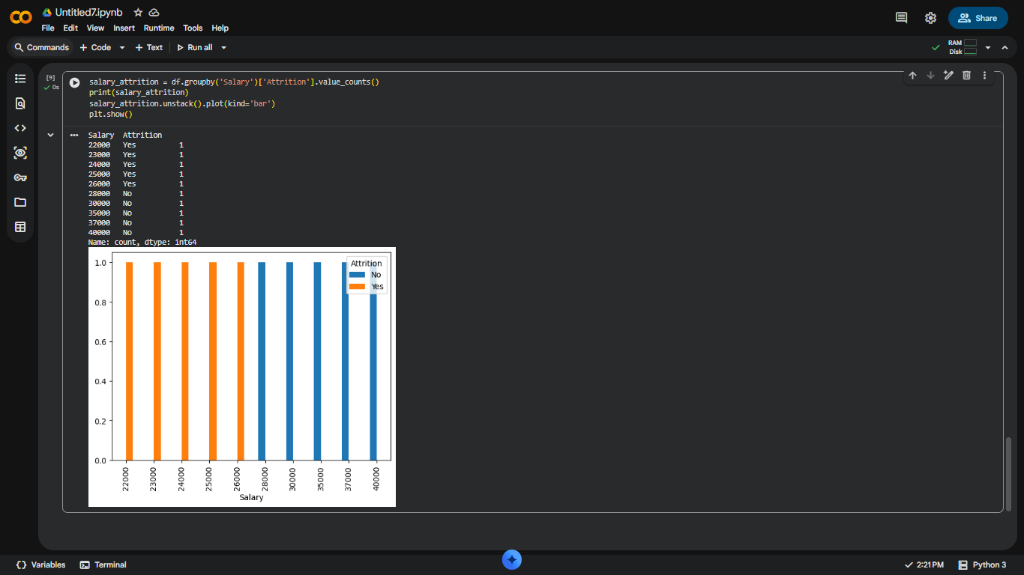

- Pie Chart Visualization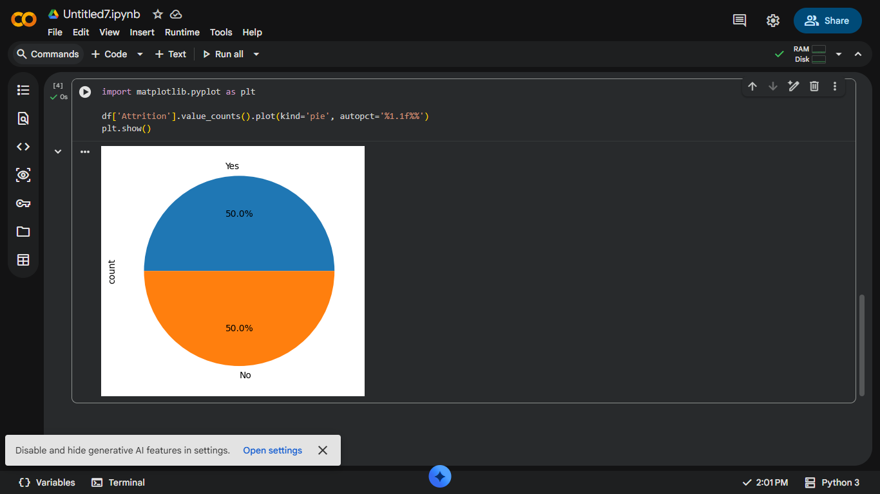
- Bar chart visualization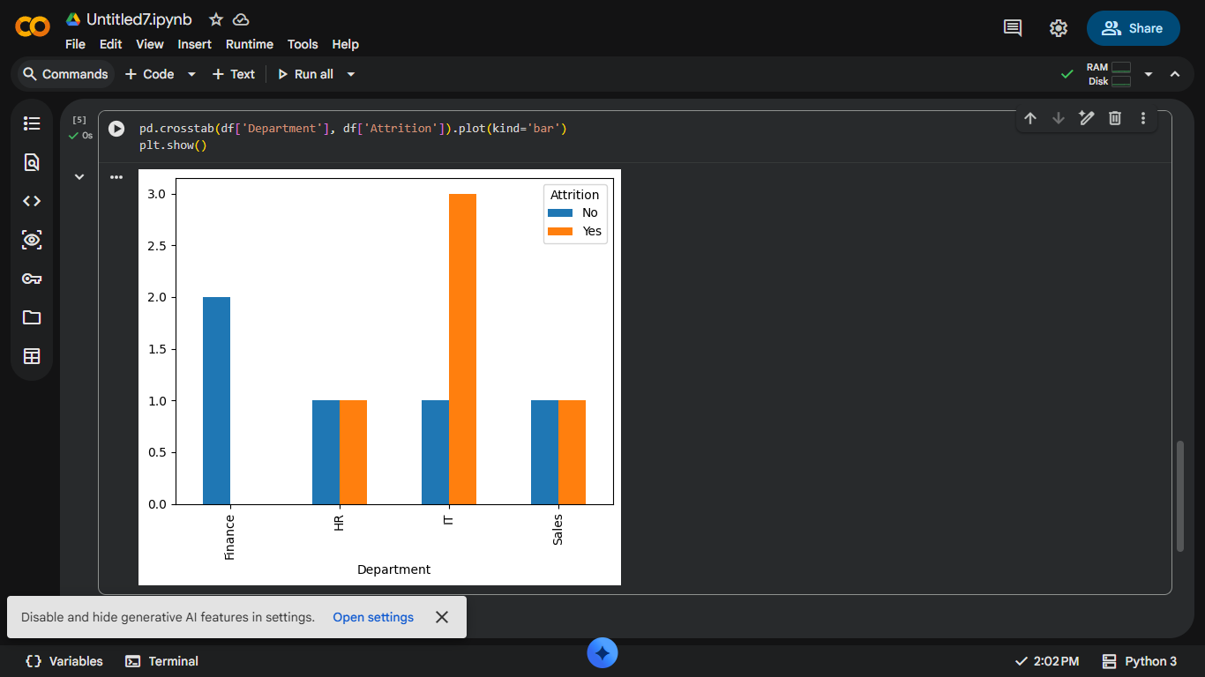

9. CHALLENGES FACED

- Handling missing values in the dataset.
- Cleaning duplicate records.
- Understanding relationships between different employee attributes.
- Selecting suitable visualization techniques.
- Interpreting the analytical results effectively.

10. LEARNING OUTCOMES

- Learned data cleaning and preprocessing techniques.
- Improved knowledge of Python libraries.
- Gained practical experience in Exploratory Data Analysis.
- Learned to create effective visualizations.
- Developed problem-solving and analytical skills.
- Understood real-world applications of Data Analytics.

11. CONCLUSION

The HR Employee Attrition Analysis project successfully identified important factors influencing employee turnover. Through data cleaning, analysis, and visualization, meaningful insights were obtained regarding attrition patterns across departments, salary levels, and experience categories. The findings can help organizations develop better employee retention strategies and improve workforce management. This project demonstrates the effectiveness of Python and Data Analytics in solving real-world business problems and supporting informed decision-making. HR EMPLOYEE ATTRITION ANALYSIS USING PYTHONHR EMPLOYEE ATTRITION ANALYSIS USING PYTHONHR EMPLOYEE ATTRITION ANALYSIS USING PYTHON

